6. Tuners/Lorentz Force detuning Matthias Liepe (8/25/2005)

Overview
Main objectives for the frequency tuner are to provide means to tune the cavity on resonance, detune a cavity to by-pass operation if needed, and to compensate Lorentz-force detuning. The tuner further needs to allow for a high linac fill factor (compact design), should be hysteresis free, and should not cause cross-tuning of neighboring cavities. Long life time of the tuner is essential; see discussion below. All this needs to be achieved with lowest cryogenic losses, and at low cost.

ILC requirements:
Coarse tuning range: 500 kHz (1.6 mm at 315 Hz/μm)
Coarse resolution: <5 Hz
Fast tuning range (static at 2K): Δf=2*K*E^2 (factor 2 for dynamic operation overhead)
2.5 kHz (for K=1 Hz/(MV/m)^2 cavity at 35 MV/m)
3.2 kHz (for K=1 Hz/(MV/m)^2 cavity at 40 MV/m)
4.0 kHz (for K=1 Hz/(MV/m)^2 cavity at 45 MV/m)

The requirement on fast running range is not well known at this point. Significant spread in the dynamic Lorentz-force detuning constant has been seen (factor 2 at TTF). Unless K can be controlled well in the ILC cavity/LHe vessel production, more fast tuning range is required. Also, significant difference can exist between the static range and the dynamic range (maximal frequency shift within the RF pulse length). A factor of 2 is included in the above numbers for the ratio static / dynamic range. Dedicated experiments are needed to define the actually required fast tuning range.

Table 1: Examples of frequency tuners.
 | Saclay original | Saclay modified | INFN Blade tuner | TJLAF upgrade | KEK Slide Jack Tuner | KEK coaxial ball screw
Coarse Range [kHz] | 440 | 500 | 500 | 500 | 1100 | >4000
Coarse Res. [Hz] | <1 | <1 | <1 | <1 | <100 | <120
Fast actuator | (Piezo) | Piezo | Piezo | Piezo/ Magnetostr. | Piezo | Piezo
Number of fast actuators | (1 - 2) | 2 | 2 | 2 | 1 | 1
Fast range [Hz] | <500 | 1000 | 1200 | 1000/ 30000 | 1900 | 2500
Position of fast actuator | 5 K, vacuum | 5 K, vacuum | 5 K, vacuum | 5 K, vacuum | 5 K, vacuum | 80 K, vacuum
Position of motor | 5 K, vacuum | 5 K, vacuum | 5 K, vacuum | 5 K, vacuum | Warm, outside | 80 K?, vacuum

Options under consideration:
The following existing tuners could provide a basis for the ILC frequency tuner (see also Table 1 and Figure 1 to 3):
- Original Saclay / TTF tuner: This type of tuner is in use at TTF/VUVFEL since several years and thus is well tested. It does not have a fast tuning element, though a piezo actuator has been added for prove-of-principle tests of Lorentz-force detuning. The range however of the fast tuner is below 500 Hz, and the tuner was not initially developed to implement a piezo actuator.
- Modified Saclay tuner (see Figure 1): Similar the original Saclay tuner, this tuner is located at one end of the cavity. The redesign however is more compact, and incorporates piezo actuators (about 1 kHz tuning range). First tests of this tuner are expected by end of 2005.
- INFN / DESY blade tuner (see Figure 1): The first version of this tuner did not include fast actuators, and was tested at TTF with the superstructure. This tuner is located around the LHe vessel, thus does not require any clearance at the cavity ends. The recent version of this tuner includes piezo actuators (about 1 kHz tuning range), and will be tested late 2005.
- TJNAF Renascence tuner (see Figure 1): This tuner was developed for the TJNAF upgrade cryomodule. It does incorporate piezo actuators (about 1 kHz tuning range), and eight tuners of this type will be operated and tested in a cryomodule test late summer 2005.
- KEK slide jack tuner: KEK design for cavity operation at the baseline gradient of 35 MV/m. The uniqueness of this design is that the motor is placed at room temperature outside of the vacuum vessel.
- KEK coaxial ball screw tuner: This tuner was designed for the ICHIRO 9-cell cavity at 45MV/m. Both, the motor and the piezo are placed at intermediate temperature inside of the vacuum vessel. A first prototype test is planed for late summer 2005.

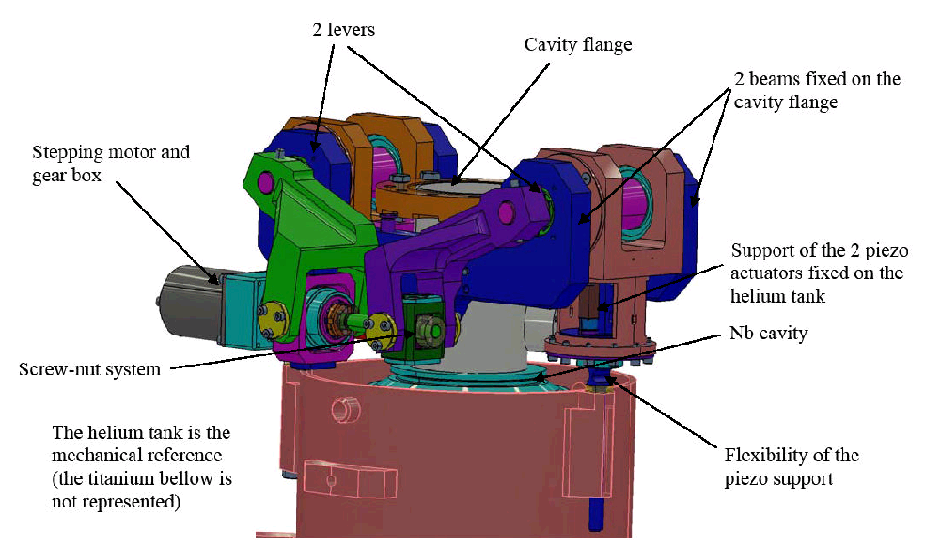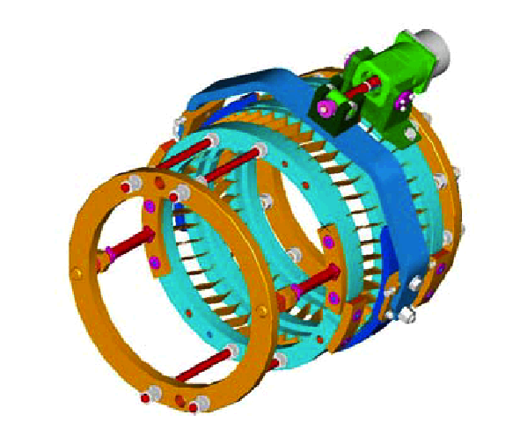

Figure 1: Left: New Saclay tuner. Right: INFN tuner.

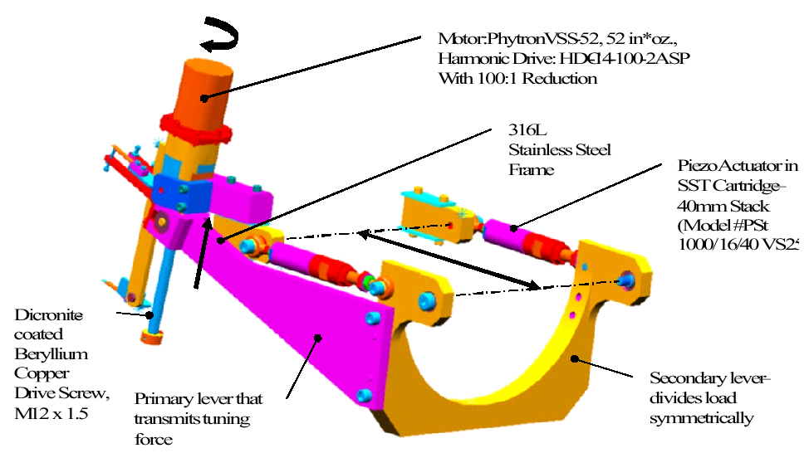

Figure 2: TJNAF tuner

Figure 3: Left: KEK slide jack tuner. Right: KEK coaxial ball screw tuner.

Risk and Reliability impacts:
All but one of the above mentioned designs have a cold drive motor inside the vacuum vessel. In none of the designs can the fast actuator be replaced without cryostat warm-up. Highest reliability / lifetime are therefore essential. The main risk is a failure of the motor, the fast actuators or the gearing. All designs with cold drive can use the same type of motor, gearing and fast actuator, so that there is no principle difference in risk and reliability between these tuner designs. A well tested version of the motor and gearing exists. Tests on piezo performance and reliability are underway. However, the reliability of a single cold drive might not be sufficient, as was pointed out by the U.S. Linear Collider Technology Options Study: “The cavity tuners and cavity piezo tuners designs both require opening the cryostat to effect repairs and had over 50 failures per year. This is an unreasonable amount of work even for the 3 month shutdown. The tuners will either have to be made very reliable (probably via redundancy) or their failure prone components made replaceable without warm-up.”

To improve reliability, the following options exist:
- Redundant motor and piezo, if inside of vacuum vessel
- Improved design with highest reliability for motor and/or piezo, if inside of vacuum vessel
- Warm motor

It should be pointed out, that the operation of the fast actuator is essential at high fields. A failure of this element will result in lower operating fields. The motor on the other side is only operated during cool-down and warm-up, and to correct for slow frequency drifts. A failure of the motor will not immediately impact the cavity operation. It can be expected that to total required step-count of the motor is moderate. The failure mechanism and the MTBF in this operating mode need to be studied in detail, to verify if a cold motor is acceptable.

Fast actuator:

To options are under consideration:
- Piezo actuator (used in all designs as baseline). Detailed studies have been done to verify pulsed cryogenic operation in radiation environment.
- Magnetrostrictive actuator (similar size to piezo, so can be used instead of piezo in all discussed tuner designs): Has a significant larger stroke than a piezo at 5 K, produces less heat and might have a higher lifetime and higher tolerance for preload change than piezo. First test at cryogenic temperatures have been done. A detailed characterization is need. This actuator needs a high drive current, and its residual magnetic needs to be studied. Also, the cost of this actuator type might be higher.

BCD choice

Not available. No existing tuner design fulfills the specification on fast tuning range above 30 MV/m. The above mentioned designs give a good starting point for an ILC tuner and for a cost estimate. The tuner needs to provide 500 kHz slow tuning range and more than 3 kHz fast tuning range. The fast actuator should be located inside the vacuum vessel for best performance during Lorentz-force compensation. A redundant design for the fast actuator is important for reliability.

R&D for BCD:
  - Tuner design for 40+MV/m operation and prototype tests including demonstration of Lorentz-force detuning at highest fields with BCD cavity.
  - Reliability (MTBF) studies of motor / gearing / piezo / magnetostrictive actuator, including failure mechanisms and improved estimate of requirements.
  - Performance of magnetostrictive actuator.
  - Cavity design with smaller Lorentz-Force detuning.
  - Cost estimation for external motor.

Close to BCD:

- Modified Saclay tuner:

Pros:
Relative simple and compact design
Redundant design for piezo element
Original Saclay tuner was tested in detail

Cons:
Maybe difficult to increase fast tuning range
Redesign needed with increased fast tuning range
Poor maintainability of stepping motor and fast actuator
Requires some length between cavities (located at cavity end)

R&D necessary:
Design with increased fast tuning range
Fast actuator R&D
Prototype tests with Lorentz-force compensation at 35 MV/m
Verification of sufficient MTBF for cold motor

- INFN blade tuner:

Pros:
Compact design (not at cavity end)
High stiffness
Tested (without fast actuator)
Relative easy to increase fast tuning range

Cons:
Redesign needed with increased fast tuning range
Poor maintainability of stepping motor and fast actuator

R&D necessary:
Design with increased fast tuning range
Fast actuator R&D
Prototype tests with Lorentz-force compensation at 35 MV/m
Verification of sufficient MTBF for cold motor

ACDs choices

- TJNAF Renascence tuner:

Pros:
Compact and simple design (not at cavity end)
Low cost?

Cons:
Not originally designed for ILC cryomodule. May need some redesign to fit.
Redesign needed with increased fast tuning range
Poor maintainability of stepping motor and fast actuator

R&D necessary:
Design for ILC cryostat
Design with increased fast tuning range
Fast actuator R&D
Prototype tests with Lorentz-force compensation at 35 MV/m
Verification of sufficient MTBF for cold motor

- KEK slide jack tuner:

Pros:
Motor outside of vacuum vessel (inexpensive motor)
Piezo can be replaced (cryostat warm-up required)
High stiffness

Cons:
Feed-through to outside needed (penetration of shields and vacuum vessel)
Some static losses (0.05 W?)
Redesign needed with increased fast tuning range
Poor maintainability of fast actuator; no redundancy

R&D necessary:
Design with increased fast tuning range
Fast actuator R&D
Prototype tests with Lorentz-force compensation at 35 MV/m

- KEK coaxial ball screw tuner:

Pros:
Wide tuning range
Compact design with common technology
Cost effective
High stiffness
Maybe access to piezo (warm-up required; need to pass through all thermal shields)

Cons:
Poor maintainability of stepping motor
Poor maintainability of fast actuator; no redundancy
Heavy weight
Some static losses
Redesign needed with increased fast tuning range

R&D necessary:
Choice of coating material for balls
Weight reduction
Design with increased fast tuning range
Fast actuator R&D
Prototype tests with Lorentz-force compensation at 35 MV/m
Verification of sufficient MTBF for cold motor

